Abhinav Jain

500083840

EXPERIMENT-4

Title: 4. Use of Inbuilt functions and relational algebra operation

Objective: To understand the use of inbuilt function and relational algebra with sql query.

1. Create the following two tables (EMP and DEPT)

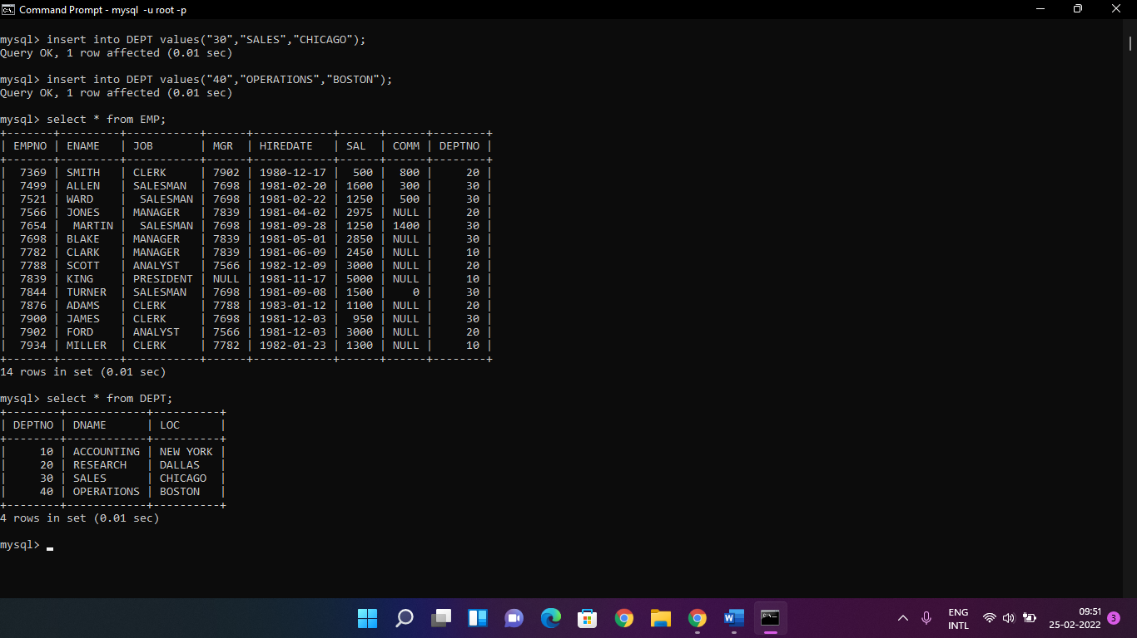

Write the Nested Queries for the following queries.

1. List the details of the emps whose Salaries more than the employee BLAKE.

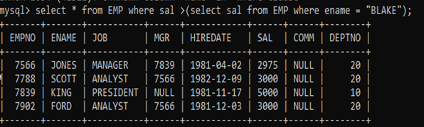

1. List the emps whose Jobs are same as ALLEN.

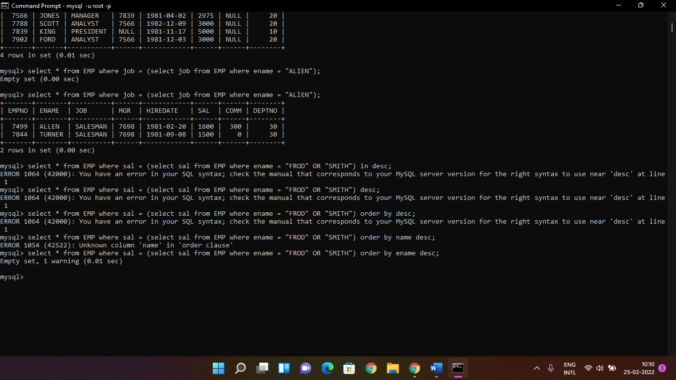

4. List the emps Whose Jobs are same as MILLER or Sal is more than ALLEN.

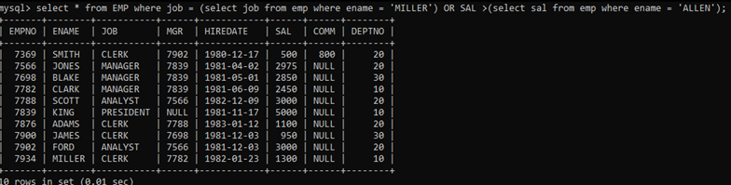

5. Find the highest paid employee of sales department.

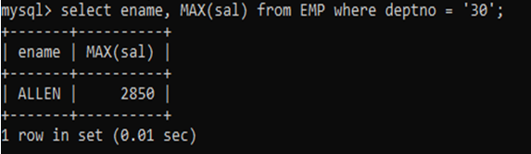

6. List the employees who are senior to most recently hired employee working under king.

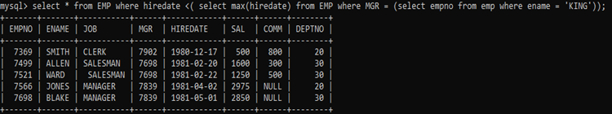

7. List the names of the emps who are getting the highest sal dept wise.

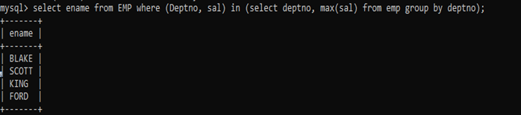

8. List the emps whose sal is equal to the average of max and minimum

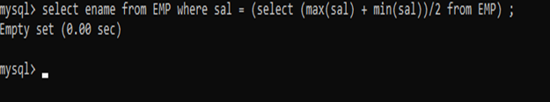

9. List the emps who joined in the company on the same date.

